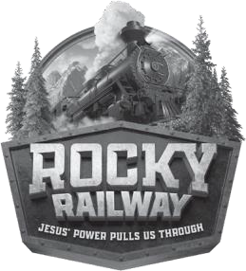
Registration Form
(One Per Child)

Child’s name: Child’s gender:

Child’s age: Date of birth: Last school grade completed:

Name of parent(s):

Street address:

City: State: ZIP:

Home telephone: ( )

Parent/caregiver’s cellphone: ( )

Home email address:

Home church:

Food Allergies:

I would like to purchase a Sing and Play Express Music CD
$6.99/ea This will have all the music in VBS (It is not necessary, but fun to have. Great music!)
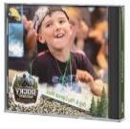

# CD X $6.99 Total amount due $ ____ Payable to NUMC

Send check to: Newtown United Methodist Church
35 Liberty Street, Newtown, PA 18940

Permission to photocopy this resource from Group’s Rocky Railway VBS granted for local church use.
Copyright © 2020 Group Publishing, Inc., Loveland, CO. group.com/vbs

